**Microsoft Project 2016: Tutorial 5a**

**Setting up Resources**

**1. Introduction**

In any project, resources are required for tasks to be performed. Resources are things such as People, Equipment, Buildings and Funding. MS Project allows us to add resources to a project, allocate resources to tasks and optimise the scheduling of tasks/resources.

MS Project makes use of 3 different resource types:

* Work resources (the people and equipment needed to complete tasks)
* Cost resources (the financial cost associated with a task)
* Material resources (the consumables used by a project)

In this tutorial, we will only be concerned with Work resources.

**2. Adding work resources to a project**

Start MS Project and open “SimpleSoftwareProject”. We are going to add the following resources:

|  |
| --- |
| **Resource** |
| Dave Cross (software designer) |
| Julie Morris (software designer) |
| Suchith Anand (software developer) |
| Andrew O’Brian (software developer) |
| Sue Richards (software tester) |
| Peter Watkins (software tester) |

Click the View tab, and then from the Resources View Group click on Resource Sheet. Enter the resource names (taken from the table above) – all other values will be automatically added. Note - on this module we will not be using MS Project to monitor costs, so all items relating to cost can be left as £0.00.

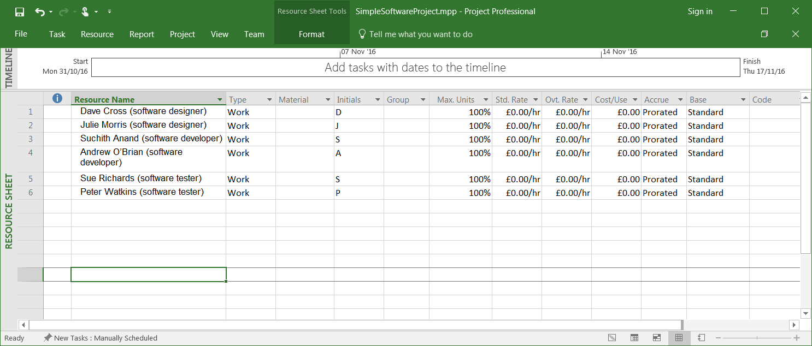

The Max Units field defines the maximum capacity of a resource to work on assigned tasks. 100% stands for 100 percent of resource’s working time is available for work on task assigned. The resource is available full-time on each workday. If the resource gets allocated to task or tasks that would require more than his/its work hours, the resource is over allocated and MS Project will indicate this in red formatting.

If a resource is only available to the project on a part-time basis, then the Max Units value can be lowered to reflect this. For example (don’t do this, leave your project as it is):

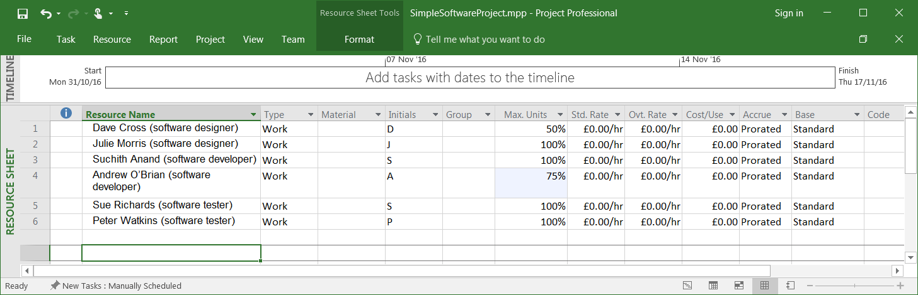

If a resource does not represent an individual person but a job function, where a group of people with the same skill set can work on the task, we can enter larger Max Units to represent the number of people in the group. So, 400% would indicate, 4 individual people working full-time every workday. So, as an alternative to above, we could have had (don’t do this, leave your project as it is):

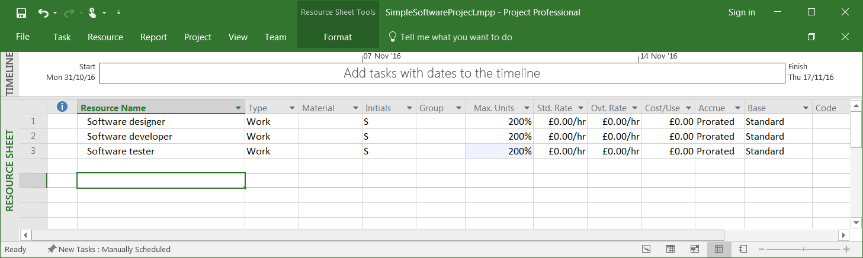

**3. Assigning resources to tasks**

Now we must assign resources to tasks. This can be done in several ways:

3.1. Click the View tab, and then from the Task Views Group click on Gantt Chart View. In the Resource Name column (you will need to expand the Gantt Chart if this column is not showing) click in the first cell (the row corresponding to the Design admin software task). Use the drop down menu to select Dave Cross (software designer) as the allocated resource:

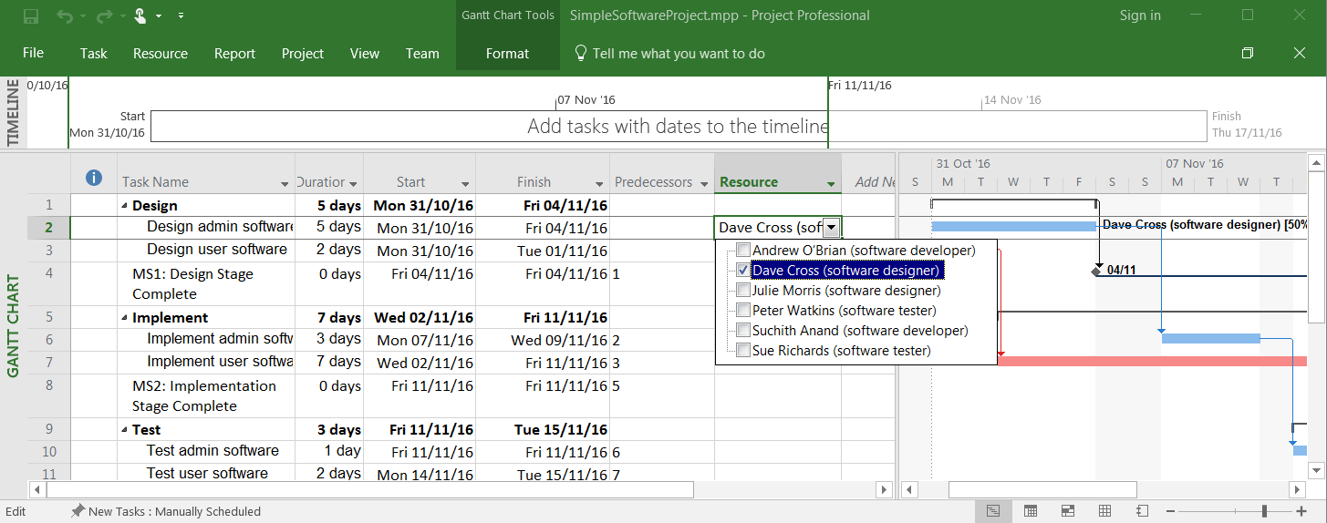

Add the other resources to produce:

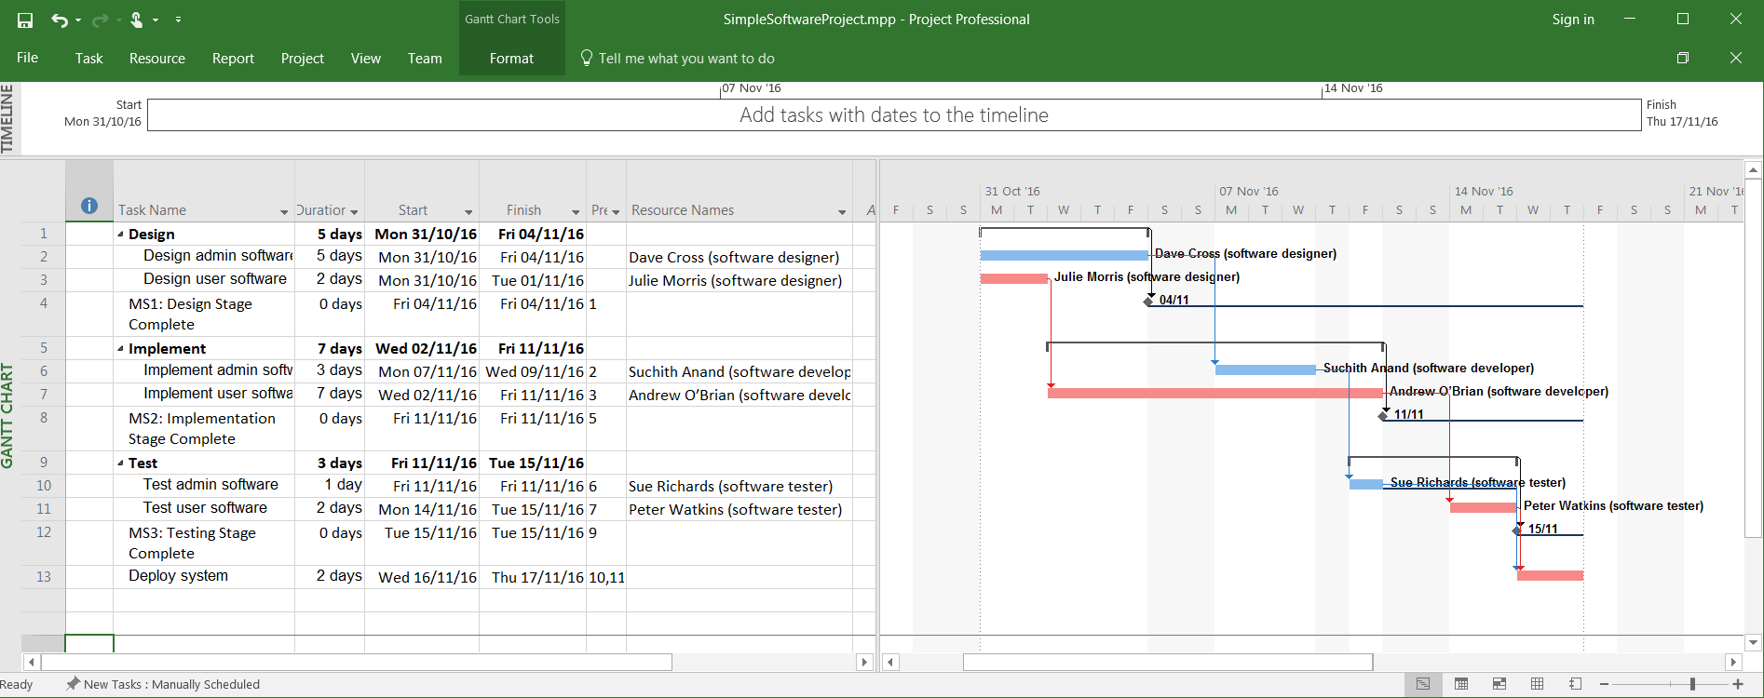

Notice that the resource names are displayed alongside the corresponding task bar in the timeline.

3.2 There are other ways of assigning resources to tasks. For example, in the Resource tab there is the Assign Resources button (part of the Assignments group). You can also directly edit a task via its Task information dialog box. Please feel free to experiment with these alternative methods.

**4. Over-allocating resources**

Let’s consider a situation where Andrew O’Brian (software developer) is no longer available to the “SimpleSoftwareProject” – maybe he has joined another project, or perhaps moved to a different company. He needs to be removed from the list of resources. Open the Resource Sheet (View Tab, Resource Views group) and delete Andrew O’Brian (software developer) – select the correct row, right-click and select Delete Resource:

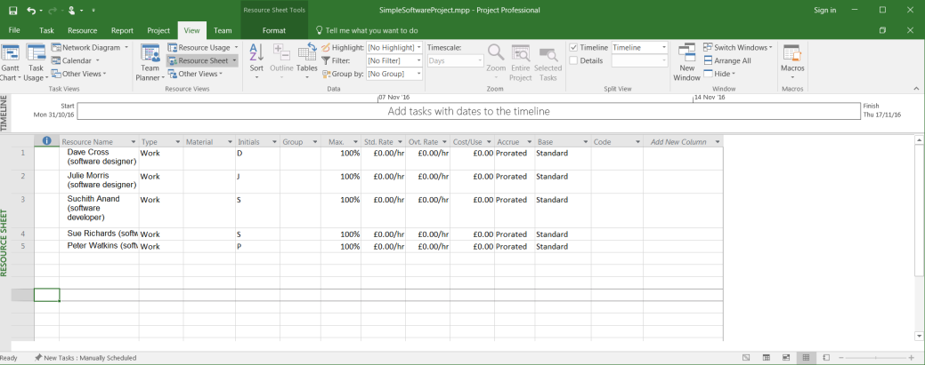

Switch back to Gantt Chart view. You will notice that Andrew O’Brain (software developer) has been removed as the allocated resource of task Implement user software. We need to allocate an alternative resource. Looking at the resource sheet, it should be apparent that the only suitable resource is Suchith Anand (software developer) – so allocate him to the task:

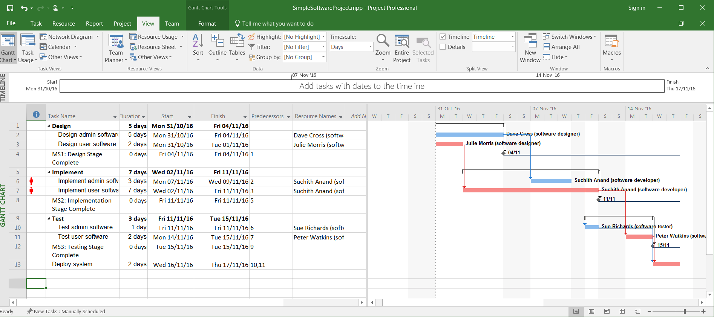

This presents us with a problem. Look at the current project schedule. It shows that Suchith Anand is now allocated to 2 tasks – Implement admin software and Implement user software. This is not in itself a problem. However, notice that for a certain period (Mon 7th November – Wed 9th November) these tasks are scheduled to run in parallel. This does present us with a problem – for those 3 days Suchith Anand is scheduled to be undertaking 2 different tasks at the same time. This is not allowed. MS Project identifies this as a problem by displaying red icons in the task sheet’s information column.

**5. Resource levelling**

There are various ways in which the above problem can be overcome. First, there are manual approaches. One method would be to manually change start date of one of the problem tasks could be changed so that it is scheduled to run after the completion of the other problem task. Alternatively, the precedence information relating to one of the tasks could be updated to include the other task as a predecessor.

An easier option is to use MS Project’s resource levelling functionality. Switch to the Resource tab and look at the Level group. Click on the Level Resource button. The following window should appear:

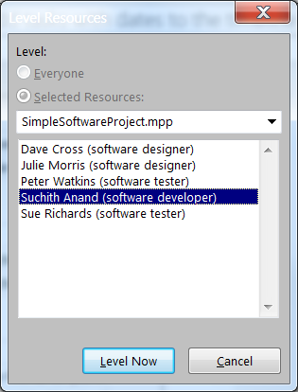

Select Suchith Anand (software developer) from the list of resources and click on the Level Now button:

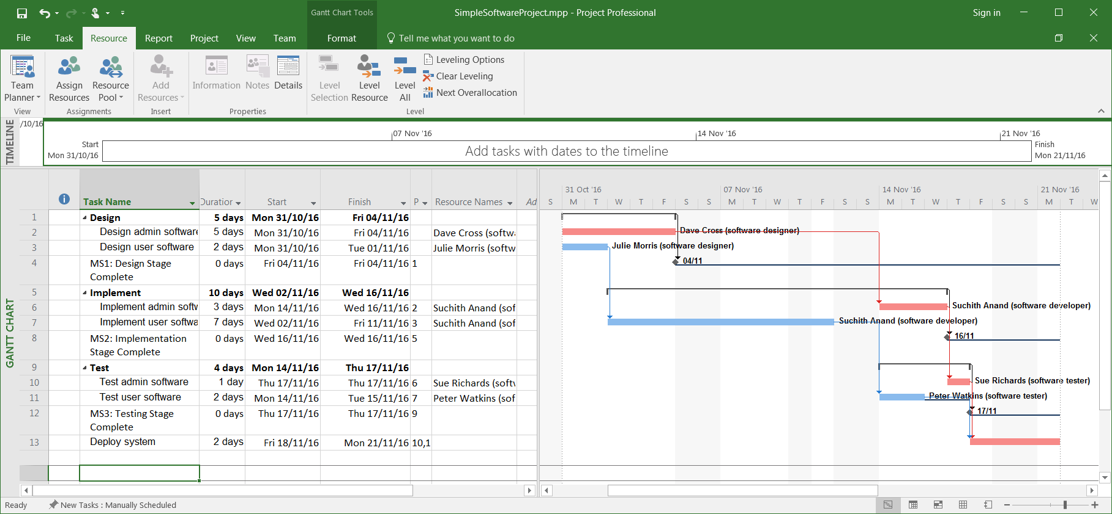

You should notice that the project plan has been updated – in particular, the tasks associated with Suchith Anand have been re-organised to reflect the fact that he cannot be in two places at once. This process is known as Resource Levelling. It should be apparent to you that levelling can be applied to single resources or to all resources at once.

Also, notice that the project completion date has been pushed back from 17/11/16 to 21/11/16. This delay may or may not be acceptable to the project team. If not, an alternative solution would need to be found – perhaps by hiring somebody to replace Andrew O’Brian, or maybe by reallocating resources (e.g. Dave Cross might also have developer skills).

**6. A problem with the critical path**

The more observant among you might also have noticed that the project’s critical path is no longer valid. Remember, the critical path is made up of those tasks that cannot be delayed or extended without a corresponding delay or extension to the project finish date. Tasks not on the critical path can be delayed (the length of delay will be dependent on the task’s float value). Note however that in your resource levelled project, any delay or extension to task 3 or task 7 will delay project completion – even though they are not on the critical path. This might be perceived as a problem from a project management perspective, and it stems from the fact that, in its purest form, CPA is a scheduling tool that pays no attention to resources (i.e. it assumes a project has sufficient resources available always). An alternative to traditional CPA does exist; it is called the Resource Critical Path. However, most project management software applications (including MS Project) do not include it.

Several workarounds exist. The most popular seems to be to force the start date of relevant tasks to be delayed by updating the predecessor list associated with those tasks. In our current project this might involve:

6.1 Add a custom column named “Resource driven predecessor” (you will hopefully be able to work out how to add a custom column).

6.2 Add task 7 (Implement user software) to the “Predecessor” list of task 6 (Implement admin software).

6.3. Add task 7 to the “Resource driven predecessor” list of task 6. This column serves only as a reminder of which of the predecessors are resource driven. This information might be useful at later stages of the project (say, for example, if additional resources become available).

The project should now look like:

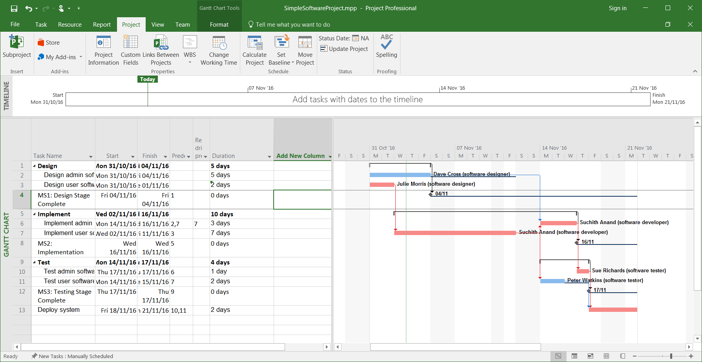

Save your project, you will need it again.

**6. Practice**

Load the “BuildRestaurant” project.

Add the following resources:

|  |
| --- |
| **Resource** |
| Tim Burden (builder) |
| Paul Wilson (electrician) |
| Amanda Winston (decorator) |
| Hamed Amiri (project manager) |
| Sam Peters (purchaser) |

Allocate resources to tasks as shown:

|  |  |
| --- | --- |
| **Task name** | **Resource** |
| Obtain planning permission | - |
| Purchase building materials | Sam Peters |
| Purchase equipment | Sam Peters |
| Select and hire contractors | Hamed Amiri |
| Prepare site | Tim Burden |
| Build the new restaurant | Tim Burden |
| Install mains services | Paul Wilson |
| Install equipment | Paul Wilson |
| Decorate | Amanda Winston |
| Purchase consumables | Hamed Amiri |
| Hire staff | Hamed Amiri |
| Train staff | Hamed Amiri |
| Open restaurant | - |

Resource level the project.

If necessary, add in resource driven predecessors to “improve” the critical path.

Save your project, you will need it again.

**Microsoft Project 2016: Tutorial 5b**

**Resource Cost**

One thing we didn’t consider in Tutorial 5 (Setting up resources) is the cost associated with a work resource. MS Project allows you to enter standard rates and overtime rates for work resources. These rates are then used to calculate the cost of a task by using the formula:

Cost of Task = Work Value (in number of hours/days/weeks) x Resource’s Pay Rate.

Cost of tasks can then be added to give the work resource cost of Summary Tasks and work resource cost of the entire Project.

**1. Getting started**

Start MS Project and open “SimpleSoftwareProject”.

**2. Edit the resource sheet**

Switch to the View tab and select Resource Sheet from the Resource Views group:

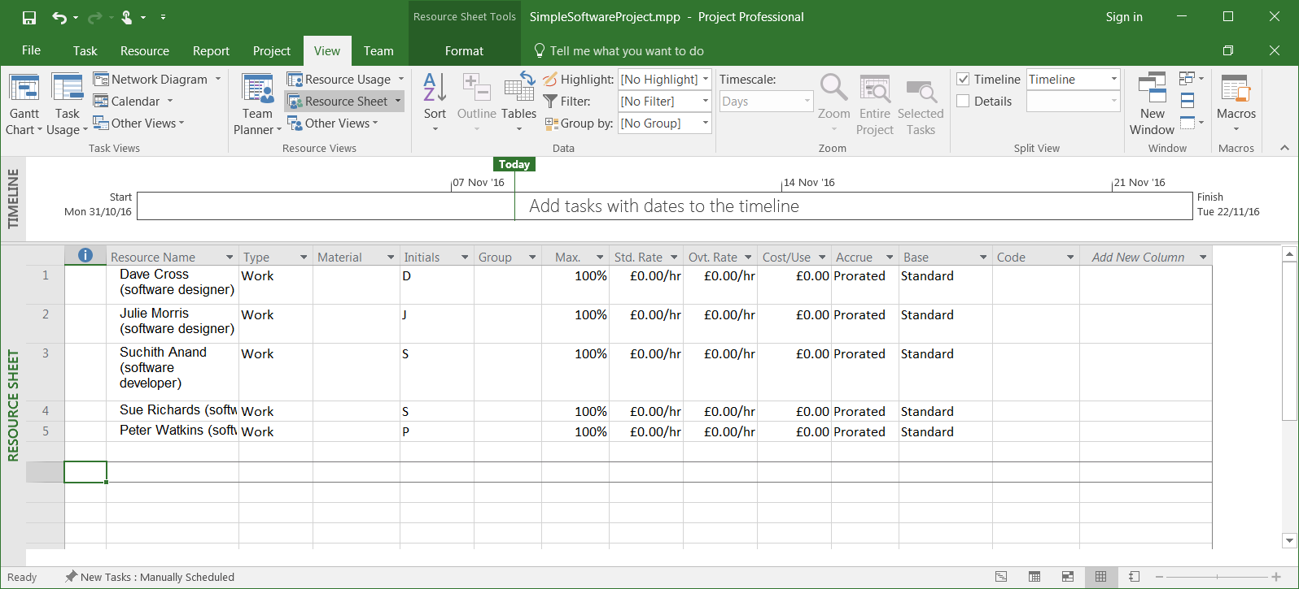

Enter the following payrates in the Std. Rate. Column. Make sure to use days as your unit of time (the default is hours) – do this by, for example, typing in “750/d”:

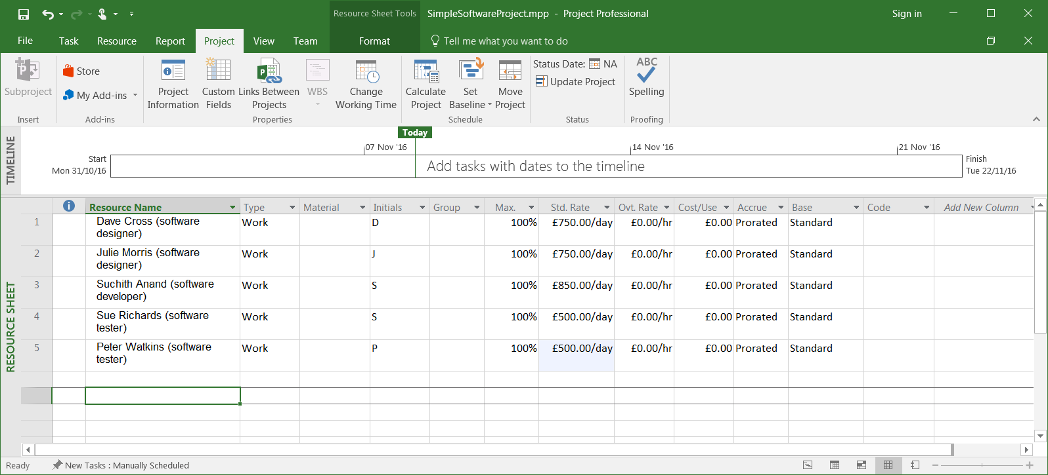

**3. Display task cost**

There are several ways of viewing the calculated cost per task. One approach is to switch to the View tab, open the drop-down menu on the Gantt Chart menu button (left hand side of menu bar), and select More Views. Select Task Sheet from the Views list that appears, and then click Apply. Stay in the View tab and open the drop down-menu on the Tables menu button (part of the Data group). Select Summary from the list:

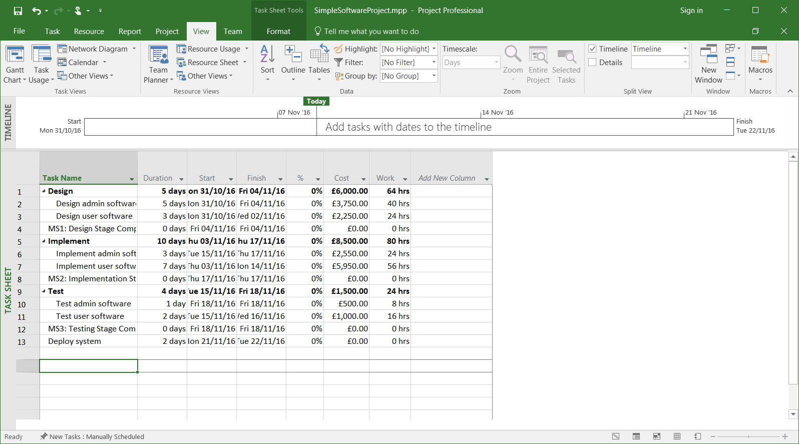

This datasheet contains a column displaying the calculated cost of each task (including summary tasks).

Switch back to Gantt Chart view. To display the schedule (the display we have been using most of the time to date), simply select Schedule from the Tables drop-down menu.

Save your project, you will need it again.

**4. Practice**

Load the “BuildRestaurant” project.

Add the following resource costs:

|  |  |
| --- | --- |
| **Resource** | **Cost (per day)** |
| Tim Burden (builder) | £500 |
| Paul Wilson (electrician) | £500 |
| Amanda Winston (decorator) | £400 |
| Hamed Amiri (project manager) | £550 |
| Sam Peters (purchaser) | £400 |

Look at the task costs by switching to Summary view (as described in 3.).

Save your project.